PRACTISE PROGRAM

- Write a C program to perform the following:
a) Linear search
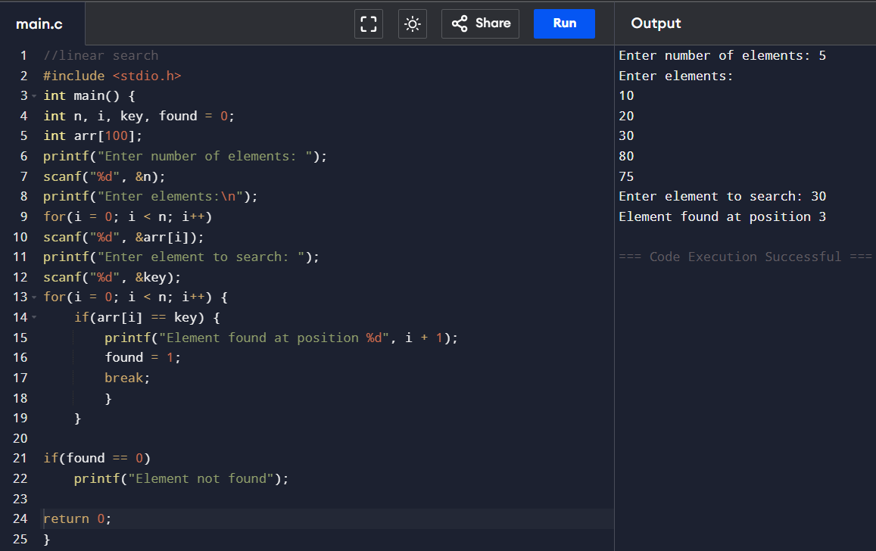

b) Binarysearch.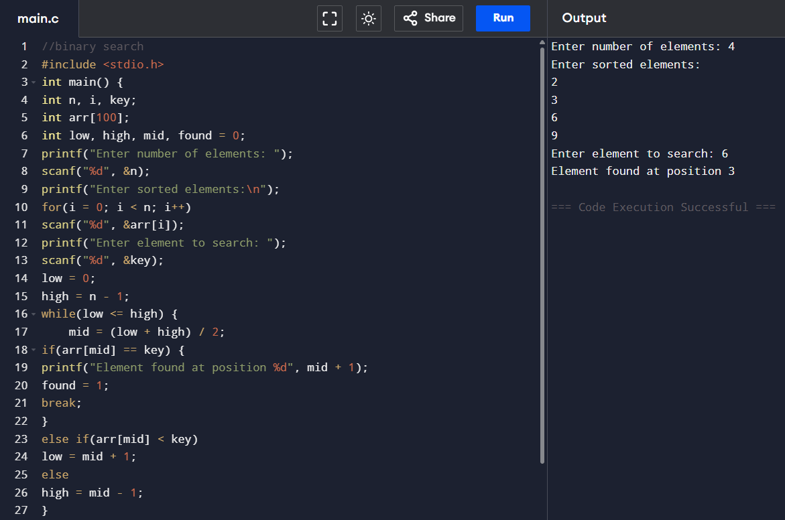

- Write a C program to print the smallest number and its position in an array of size n.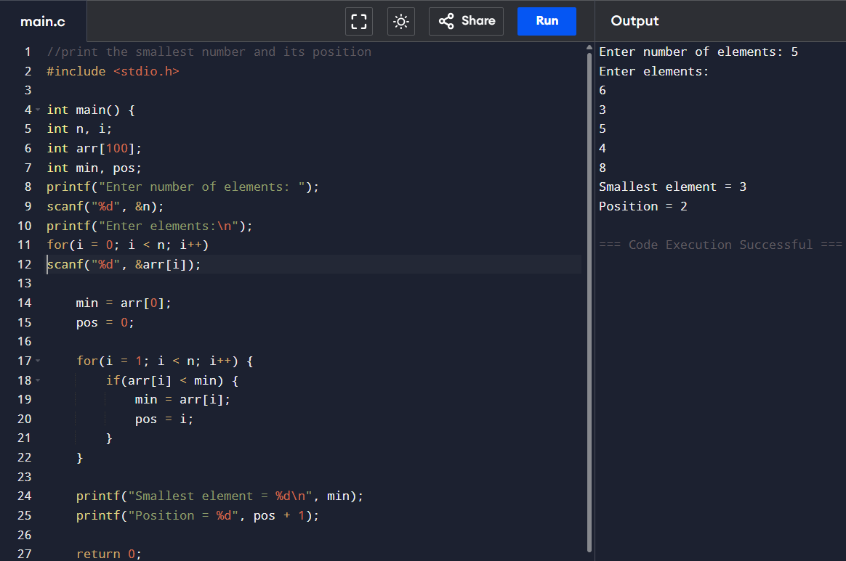

- Write a C program to find if there are duplicates in an array.